Practice Plan – Day 9

EQUIPMENT NEEDED:

- Baseballs
- Tennis balls
- Whiffle balls
- Cage and L screens
- Bases
- Hitting “sticks”
- Tees
- Ladder/paddles
SET UP/ANNOUNCEMENTS/COLLECT ORDER FORMS
VIKING STRETCH – 5min
SPLIT INTO TEAMS – 30min rotations
CONCRETE GYM - HITTING

Stations

-Regular Tee
-Top/Bottom Hand
-Side Toss (wiffle hitting sticks)
-Front Toss
-Bunt Tournament
-Live in Cage

MAIN GYM – DEFENSE
- Throwing progression
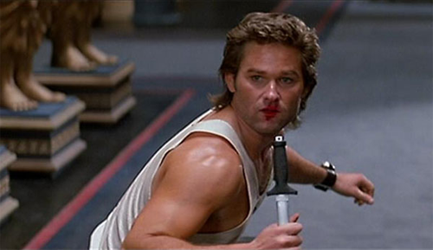
  - JV – Pitching Lessons
- Individual Defense – stations
- Varsity – Mass Fungo – OF HIT
- Varsity – Bunt Defense – OF RUNNERS
- JV/Fresh – Mass Fungo

BASERUNNING combined
- Run through 1st
- Round 1st
- Lead-offs/secondary – 1st to 3rd
- Score from 2nd (1/2 out lead)
- 3rd base (lead-off, tag) lead-off, score

4CORNER PICK OFF
NOTES:

TO PLAYERS:

-Bring your Packets? (everyday)
-Outside Clothes
-Insurance Card/Athletic Fee
-Did you get a text from Maxpreps?
-8 DAYS until first pitch
-Parents Meeting – Monday March 11

